Operating System (CS301)

Assignment - 5

**U19CS012**

**1.** To implement **First Fit, Best Fit** and **Worst Fit** storage allocation algorithms for memory management.

**Description**

* A set of **holes**, of various sizes is scattered through the memory at any given time.
* When a process arrives and needs the memory, the system **searches for a hole** that is large enough for this process.
* The first-fit, best-fit and worst-fit are strategies used to select a free hole from the set of available holes.

**Implementation details**

* Free space is maintained as a linked list of nodes with each node having the starting byte address and the ending byte address of a free block.
* Each memory request consists of the **process-id** and the **amount of storage space** required in bytes.
* Allocated memory space is again maintained as a linked list of nodes with each node having the process-id, starting byte address and the ending byte address of the allocated space.
* When a process finishes (taken as input) the appropriate node from the allocated list should be deleted and this free disk space should be added to the free space list.
* [Care should be taken to merge contiguous free blocks into one single block. This result in deleting more than one node from the free space list and changing the start and end address in the appropriate node].

**First-Fit**

Allocate the first hole that is big enough. Searching can start either at the beginning of the set of holes or where the previous first-fit search ended. You can stop searching as soon as you find a free hole that is large enough.

**Best-Fit**

Allocate the smallest hole that is big enough. You must search the entire list unless the list is kept ordered by size. The strategy produces the smallest leftover hole.

**Worst fit**

Allocate the biggest hole.

**Code**

*#include* <bits/stdc++.h>

using namespace std;

*// Structure of Process Node*

class Node

{

public:

    int start;

    int end;

    int size;

    int id;

    Node *next;

    Node(int start, int end)

    {

*this*->start = start;

*this*->end = end;

*this*->size = end - start + 1;

*this*->id = -1;

*this*->next = NULL;

    }

};

Node *memory = NULL;

*// F(x) to Print all the Choice to User [In Particular Algorithm]*

void printSubChoice();

*// F(x) to Check if Process Exist or Not*

bool checkProcess(int processId);

*// F(x) to Deallocate the Memory*

void DeallocateMemory();

*// F(x) to Allocate Memory Using First Fit Algorithm*

void firstFit();

*// F(x) to Allocate Memory Using Best Fit Algorithm*

void bestFit();

*// F(x) to Allocate Memory Using Worst Fit Algorithm*

void worstFit();

*// F(x) to Print Memory Segment Details*

void printMemorySegment(Node *node);

*// F(x) to Display Final Summary*

void displayAll();

*// F(x) to Display Allocated Memory*

void displayAllocated();

*// Utility Function for First Fit Algorithm*

void firstFitUtil();

*// Utility Function for Best Fit Algorithm*

void bestFitUtil();

*// Utility Function for Worst Fit Algorithm*

void worstFitUtil();

*// F(x) to Print Menu of Various Algorithm*

void printMainChoice();

*// F(x) to Select Algorithm Based on Used Input*

void selectAlgorithm();

int main()

{

    int noPartitions;

    cout << "Enter No. of Partitions in Memory : ";

    cin >> noPartitions;

    Node *curr;

*for* (int i = 0; i < noPartitions; i++)

    {

        int start, end;

        cout << "Starting and Ending Address of partition " << i + 1 << " : ";

        cin >> start >> end;

        Node *newNode = new Node(start, end);

*if* (memory == NULL)

        {

            memory = newNode;

            curr = memory;

        }

*else*

        {

            curr->next = newNode;

            curr = curr->next;

        }

    }

    selectAlgorithm();

*return* 0;

}

*// F(x) to Print all the Choice to User [In Particular Algorithm]*

void printSubChoice()

{

    cout << "   " << endl;

    cout << "1 -> Entry / Allocate" << endl;

    cout << "2 -> Exit / Deallocate" << endl;

    cout << "3 -> Display Whole Memory" << endl;

    cout << "4 -> Display Allocated Memory" << endl;

    cout << "5 -> Back to Algorithm" << endl;

    cout << "   " << endl;

}

*// F(x) to Check if Process Exist or Not*

bool checkProcess(int processId)

{

    Node *tmp = memory;

    bool flag = false;

*while* (tmp != NULL)

    {

*if* (tmp->id == processId)

        {

            flag = true;

*break*;

        }

        tmp = tmp->next;

    }

*return* flag;

}

*// F(x) to Allocate Memory Using First Fit Algorithm*

void firstFit()

{

    int processId;

    int sizeNeeded;

    cout << "Enter the Process Id : ";

    cin >> processId;

*// Validation of Input from User*

*if* (checkProcess(processId))

    {

        cout << "Invalid Process Id" << endl;

*return*;

    }

    cout << "Enter Size required by Process : ";

    cin >> sizeNeeded;

    Node *tmp = memory;

    bool flag = false;

*while* (tmp != NULL)

    {

*// If Size of Block is >= than Requirement and Not Visited*

*if* (tmp->size >= sizeNeeded and tmp->id == -1)

        {

*// Mark it Visited*

            tmp->id = processId;

            int startP = tmp->start;

            int endP = startP + sizeNeeded - 1;

            int newStart = endP + 1;

*// There is Some Remaining Space in Block*

*if* (newStart <= tmp->end)

            {

                Node *newNode = new Node(newStart, tmp->end);

                tmp->end = endP;

                tmp->size = sizeNeeded;

                newNode->next = tmp->next;

                tmp->next = newNode;

            }

            cout << "Memory Allocated Succesfully!" << endl;

            flag = true;

*break*;

        }

        tmp = tmp->next;

    }

*if* (!flag)

    {

        cout << "Can't Allocate the memory for this process!" << endl;

    }

}

*// F(x) to Allocate Memory Using Best Fit Algorithm*

void bestFit()

{

    int processId;

    int sizeNeeded;

    cout << "Enter the process Id : ";

    cin >> processId;

*if* (checkProcess(processId))

    {

        cout << "Invalid Process Id" << endl;

*return*;

    }

    cout << "Enter required size by process : ";

    cin >> sizeNeeded;

    Node *tmp = memory;

    bool flag = false;

    Node *ans;

    int maxSize = INT_MAX;

*while* (tmp != NULL)

    {

*if* (tmp->size >= sizeNeeded and tmp->id == -1 and tmp->size < maxSize)

        {

            flag = true;

            ans = tmp;

            maxSize = tmp->size;

        }

        tmp = tmp->next;

    }

*if* (!flag)

    {

        cout << "Can't allocate the memory for this process!" << endl;

*return*;

    }

    ans->id = processId;

    int startP = ans->start;

    int endP = startP + sizeNeeded - 1;

    int newStart = endP + 1;

*if* (newStart <= ans->end)

    {

        Node *newNode = new Node(newStart, ans->end);

        ans->end = endP;

        ans->size = sizeNeeded;

        newNode->next = ans->next;

        ans->next = newNode;

    }

    cout << "Memory allocated succesfully!" << endl;

}

*// F(x) to Allocate Memory Using Worst Fit Algorithm*

void worstFit()

{

    int processId;

    int sizeNeeded;

    cout << "Enter the process Id : ";

    cin >> processId;

*if* (checkProcess(processId))

    {

        cout << "Invalid Process Id" << endl;

*return*;

    }

    cout << "Enter required size by process : ";

    cin >> sizeNeeded;

    Node *tmp = memory;

    bool flag = false;

    Node *ans;

    int maxSize = -1;

*while* (tmp != NULL)

    {

*if* (tmp->size >= sizeNeeded and tmp->id == -1 and tmp->size > maxSize)

        {

            flag = true;

            ans = tmp;

            maxSize = tmp->size;

        }

        tmp = tmp->next;

    }

*if* (!flag)

    {

        cout << "Can't allocate the memory for this process!" << endl;

*return*;

    }

    ans->id = processId;

    int startP = ans->start;

    int endP = startP + sizeNeeded - 1;

    int newStart = endP + 1;

*if* (newStart <= ans->end)

    {

        Node *newNode = new Node(newStart, ans->end);

        ans->end = endP;

        ans->size = sizeNeeded;

        newNode->next = ans->next;

        ans->next = newNode;

    }

    cout << "Memory allocated succesfully!" << endl;

}

*// F(x) to Deallocate the Memory*

void DeallocateMemory()

{

    int processId;

    cout << "Enter the Process ID to be Deallocated : ";

    cin >> processId;

    bool flag = false;

    Node *tmp = memory;

    int offset = 0;

*// Traverse the Linked List to Find the Process to be Deallocated*

*while* (tmp != NULL)

    {

*if* (tmp->id == processId)

        {

            flag = true;

            tmp->id = -1;

*break*;

        }

        tmp = tmp->next;

        offset++;

    }

*// If Not Found*

*if* (!flag)

    {

        cout << "No Such process is running ! " << endl;

*return*;

    }

    tmp = memory;

*while* (tmp != NULL and tmp->next != NULL)

    {

*if* (tmp->end + 1 == tmp->next->start and tmp->id == -1 and tmp->next->id == -1)

        {

            tmp->end = tmp->next->end;

            tmp->size = tmp->end - tmp->start + 1;

            Node *toDelete = tmp->next;

            tmp->next = tmp->next->next;

            delete toDelete;

        }

*else*

        {

            tmp = tmp->next;

        }

    }

    cout << "Process Exited Successfully, Memory Freed!" << endl;

}

*// F(x) to Print Memory Segment Details*

void printMemorySegment(Node *node)

{

    cout << "   " << endl;

    cout << "Start : " << node->start << endl;

    cout << "End : " << node->end << endl;

    cout << "Size : " << node->size << endl;

*if* (node->id != -1)

    {

        cout << "Process Id : " << node->id << endl;

    }

*else*

    {

        cout << "No process Allocated" << endl;

    }

}

*// F(x) to Display Final Summary*

void displayAll()

{

    Node *tmp = memory;

    int totalMemory = 0;

    int freeMemory = 0;

*while* (tmp != NULL)

    {

*if* (tmp->id == -1)

        {

            freeMemory += tmp->size;

        }

        totalMemory += tmp->size;

        printMemorySegment(tmp);

        tmp = tmp->next;

    }

    cout << "   " << endl;

    cout << "Total memory : " << totalMemory << endl;

    cout << "Free memory : " << freeMemory << endl;

    cout << "Allocated memory : " << totalMemory - freeMemory << endl;

    cout << "   " << endl;

}

*// F(x) to Display Allocated Memory*

void displayAllocated()

{

    Node *tmp = memory;

    int allocatedMemory = 0;

*while* (tmp != NULL)

    {

*if* (tmp->id != -1)

        {

            allocatedMemory += tmp->size;

            printMemorySegment(tmp);

        }

        tmp = tmp->next;

    }

    cout << "   " << endl;

    cout << "Allocated memory : " << allocatedMemory << endl;

    cout << "   " << endl;

}

*// Utility Function for First Fit Algorithm*

void firstFitUtil()

{

    int subChoice = -1;

*while* (subChoice != 5)

    {

        printSubChoice();

        cout << "Choice : ";

        cin >> subChoice;

*switch* (subChoice)

        {

*case* 1:

        {

            firstFit();

*break*;

        }

*case* 2:

        {

            DeallocateMemory();

*break*;

        }

*case* 3:

        {

            displayAll();

*break*;

        }

*case* 4:

        {

            displayAllocated();

*break*;

        }

*case* 5:

        {

            cout << "Back to Main Menu (<-)" << endl;

*break*;

        }

*default*:

        {

            cout << "Invalid Input! " << endl;

*break*;

        }

        }

    }

}

*// Utility Function for Best Fit Algorithm*

void bestFitUtil()

{

    int subChoice = -1;

*while* (subChoice != 5)

    {

        printSubChoice();

        cout << "Choice : ";

        cin >> subChoice;

*switch* (subChoice)

        {

*case* 1:

        {

            bestFit();

*break*;

        }

*case* 2:

        {

            DeallocateMemory();

*break*;

        }

*case* 3:

        {

            displayAll();

*break*;

        }

*case* 4:

        {

            displayAllocated();

*break*;

        }

*case* 5:

        {

            cout << "Back to Main Menu (<-)" << endl;

*break*;

        }

*default*:

        {

            cout << "Invalid Input\n";

*break*;

        }

        }

    }

}

*// Utility Function for Worst Fit Algorithm*

void worstFitUtil()

{

    int subChoice = -1;

*while* (subChoice != 5)

    {

        printSubChoice();

        cout << "Choice : ";

        cin >> subChoice;

*switch* (subChoice)

        {

*case* 1:

        {

            worstFit();

*break*;

        }

*case* 2:

        {

            DeallocateMemory();

*break*;

        }

*case* 3:

        {

            displayAll();

*break*;

        }

*case* 4:

        {

            displayAllocated();

*break*;

        }

*case* 5:

        {

            cout << "Back to Main Menu (<-)" << endl;

*break*;

        }

*default*:

        {

            cout << "Invalid Input\n";

*break*;

        }

        }

    }

}

*// F(x) to Print Menu of Various Algorithm*

void printMainChoice()

{

    cout << "   " << endl;

    cout << "Select the Algorithm" << endl;

    cout << "1 -> First Fit Algorithm" << endl;

    cout << "2 -> Best Fit Algorithm" << endl;

    cout << "3 -> Worst Fit Algorithm" << endl;

    cout << "4 -> Exit the App" << endl;

    cout << "   " << endl;

}

*// F(x) to Select Algorithm Based on Used Input*

void selectAlgorithm()

{

    int mainChoice = -1;

*while* (mainChoice != 4)

    {

        printMainChoice();

        cout << "Choice : ";

        cin >> mainChoice;

*switch* (mainChoice)

        {

*case* 1:

        {

            firstFitUtil();

*break*;

        }

*case* 2:

        {

            bestFitUtil();

*break*;

        }

*case* 3:

        {

            worstFitUtil();

*break*;

        }

*case* 4:

        {

            cout << "Thank you for using our Application!" << endl;

*break*;

        }

*default*:

        {

            cout << "Invalid Input\n";

*break*;

        }

        }

    }

}

**Output**

**Step 1**: Adding Memory Partitions

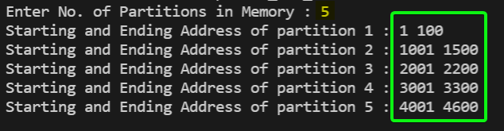

|  |  |  |
| --- | --- | --- |
| **Start** | **End** | **Size(in KB)** |
| 1 | 100 | 100 |
| 1001 | 1500 | 500 |
| 2001 | 2200 | 200 |
| 3001 | 3300 | 300 |
| 4001 | 4600 | 600 |

**Step 2**: Selecting an Algorithm

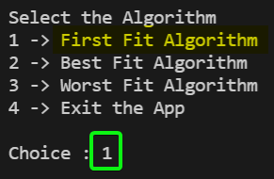

Step 3: **First Fit** Algorithm Selected

|  |  |  |
| --- | --- | --- |
| **Required Size (in KB)** | **Partition Size (in KB) used** | **New Partition created (if any)** |
| 212 | 500 | 288KB partition created |
| 417 | 600 | 183KB partition created |
| 112 | 288 | 176KB partition created |
| 426 | - | - |

Note: Using First Fit algorithm we **cannot allocate** process 4th which required 426KB of memory.

The same is displayed here in our program:

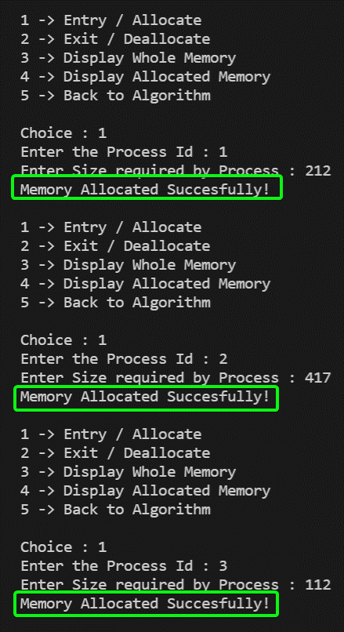

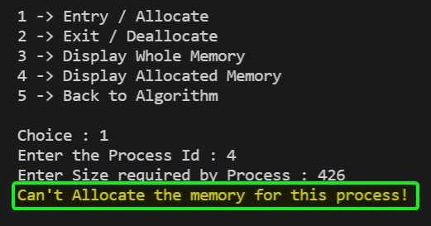

Our Memory would be as below after allocating:

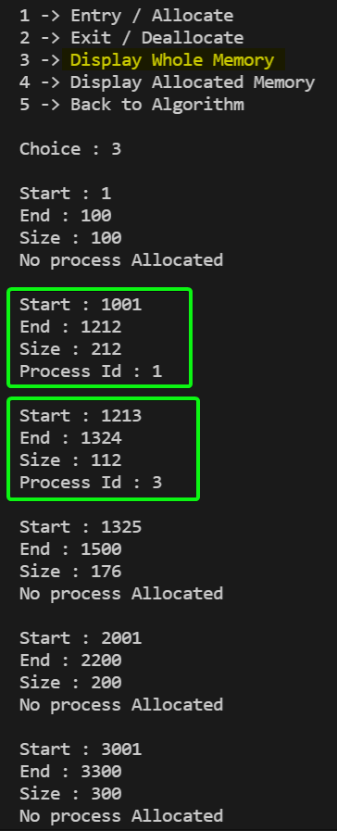 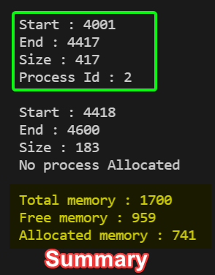

Step 4: Let’s now deallocate 2nd process using 417KB of memory.

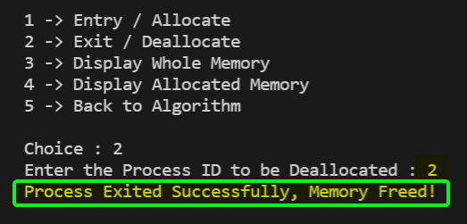

Let’s check it from our memory!

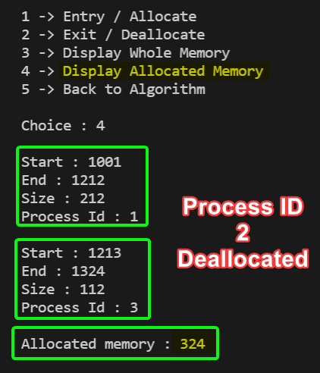

We can observe that 2nd process is no more running and allocated memory is also reduced to 324KB.

Let’s De-allocate all the memory and try another algorithm.

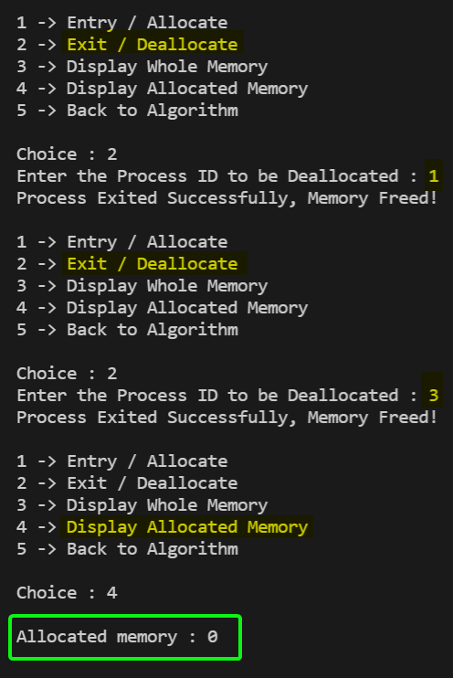

**Best Fit** Algorithm Selected

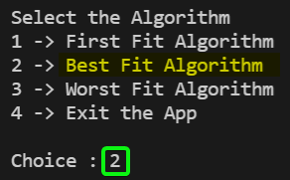

|  |  |  |
| --- | --- | --- |
| **Required Size (in KB)** | **Partition Size (in KB) used** | **New Partition created (if any)** |
| 212 | 300 | 88KB partition created |
| 417 | 500 | 83KB partition created |
| 112 | 200 | 88KB partition created |
| 426 | 600 | 174KB partition created |

Same can be observed below in our application:

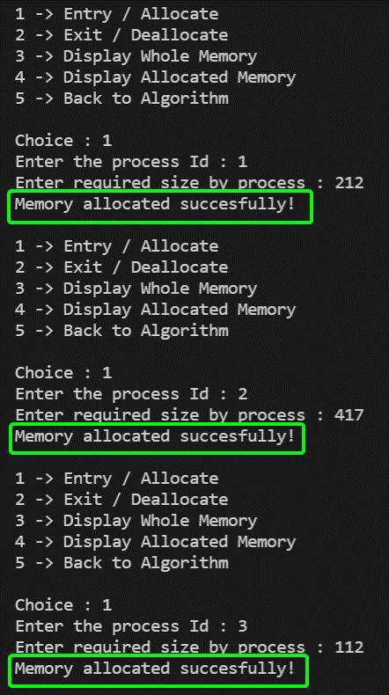 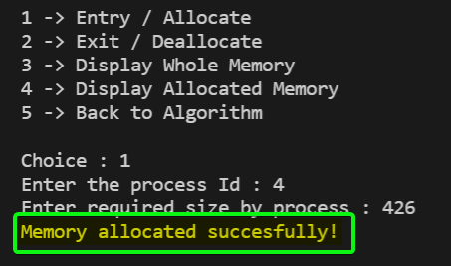

The Allocated memory looks like:

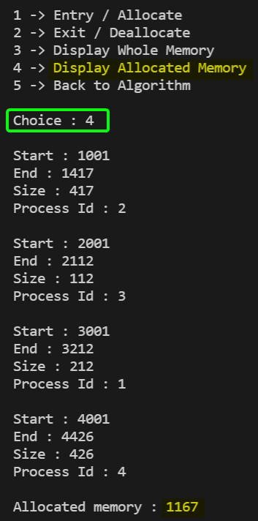

Let’s De-allocate all memory and try Worst Fit Algorithm.

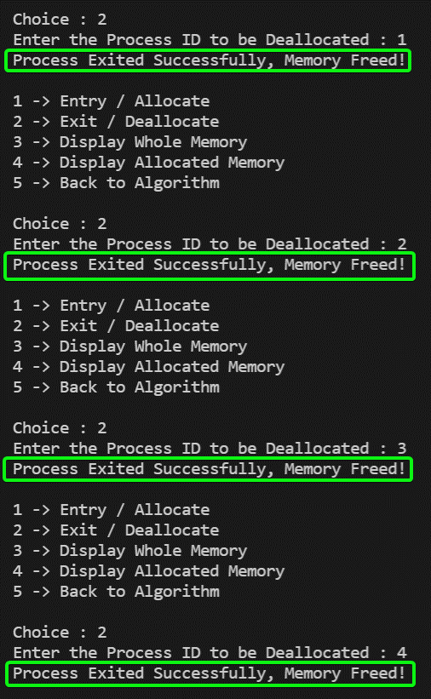

**Worst Fit** Algorithm Selected

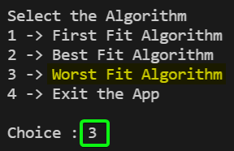

|  |  |  |
| --- | --- | --- |
| **Required Size (in KB)** | **Partition Size (in KB) used** | **New Partition created (if any)** |
| 212 | 600 | 388KB partition created |
| 417 | 500 | 83KB partition created |
| 112 | 388 | 276KB partition created |
| 426 | - | - |

We observe that 4th process **cannot** be allocated memory using Worst Fit Algorithm.

Same is displayed below:

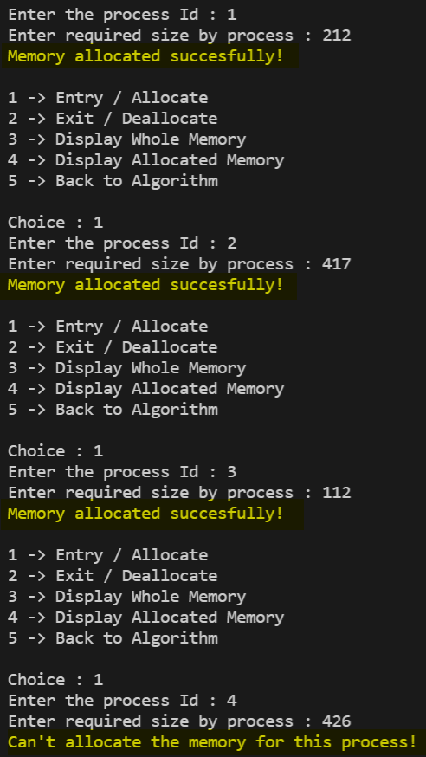

Compete Memory Structure

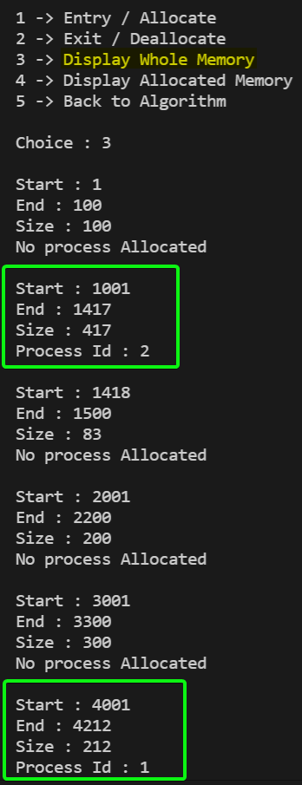 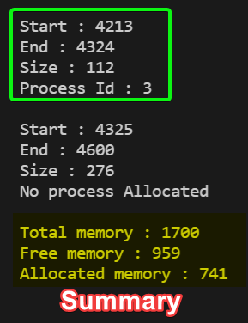

Allocated Processes in Case of Worst Fit Algorithm

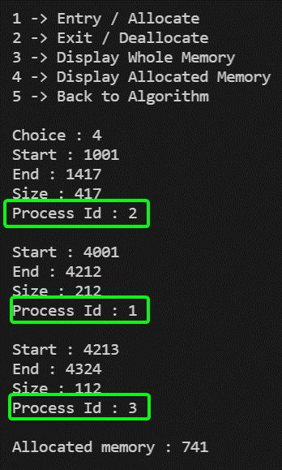

* Therefore, we observe that our **Output in Tables [Expected]** is verified by our **Application [Program is Successful].**
* We also achieved our target of **De-allocating memory** and have taken care of merging contiguous free blocks into one single block.
* This result in Deleting more than one node from the free space list and changing the start and end address in the appropriate node.

**2. Write a program that implements the following Page replacement algorithm.**

i) LRU (Least Recently Used)

In Least Recently Used (LRU) algorithm is a **Greedy algorithm** where the page to be replaced is least recently used. The idea is based on **locality of reference**, the least recently used page is not likely.

**Code**

*#include* <bits/stdc++.h>

using namespace std;

*// F(x) to Print Vector*

void print(vector<int> v);

*// F(x) to Calculate the No Of Page Faults using LRU Algorithm*

int LRU(int pages[], int n, int noFrames);

int main()

{

    cout << "L.R.U. {Least Recently Used} Algorithm\n\n";

    int n;

    cout << "Enter Number of Pages : ";

    cin >> n;

    int pages[n];

    cout << "Enter Space seperated Page Reference Number : \n";

*for* (int i = 0; i < n; i++)

    {

        cin >> pages[i];

    }

    cout << "Enter number of Frames : ";

    int noFrames;

    cin >> noFrames;

    cout << endl;

    int ans = LRU(pages, n, noFrames);

    cout << "   " << endl;

    cout << "Total Page Faults : " << ans << endl;

}

*// F(x) to Print Vector*

void print(vector<int> v)

{

    cout << "~~~~~~~~~~~~~~~" << endl;

    cout << "CURRENT PAGE ALLOCATION" << endl;

*for* (auto x : v)

        cout << x << endl;

};

*// F(x) to Calculate the No Of Page Faults using LRU Algorithm*

int LRU(int pages[], int n, int noFrames)

{

    vector<int> s;

    unordered_map<int, int> index;

    int pageFaults = 0;

*for* (int i = 0; i < n; i++)

    {

*// If set holds less pages than capacity.*

*if* (s.size() < noFrames)

        {

*// If the Page is Not Found in Set*

*if* (find(s.begin(), s.end(), pages[i]) == s.end())

            {

                s.push_back(pages[i]);

                pageFaults++;

                print(s);

                cout << "Page Fault : " << pageFaults << endl;

            }

*// If [age is Found, No Page Fault Occurs*

*else*

            {

                print(s);

                cout << "No Page Fault" << endl;

            }

        }

*else*

        {

*// Find the page in the set that was least recently used.*

*// We find it using index array. We basically need to replace the page with minimum index.*

*if* (find(s.begin(), s.end(), pages[i]) == s.end())

            {

                int lru = INT_MAX, val;

*for* (int j = 0; j < s.size(); j++)

                {

*if* (index[s[j]] < lru)

                    {

                        lru = index[s[j]];

                        val = j;

                    }

                }

                s[val] = pages[i];

                pageFaults++;

                print(s);

                cout << "Page Fault : " << pageFaults << endl;

            }

*else*

            {

                print(s);

                cout << "No Page Fault" << endl;

            }

        }

        index[pages[i]] = i;

    }

*return* pageFaults;

}

**Output**

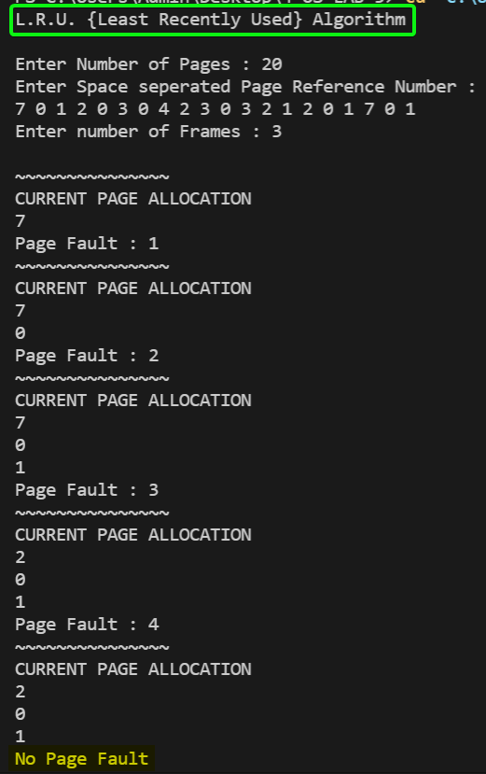

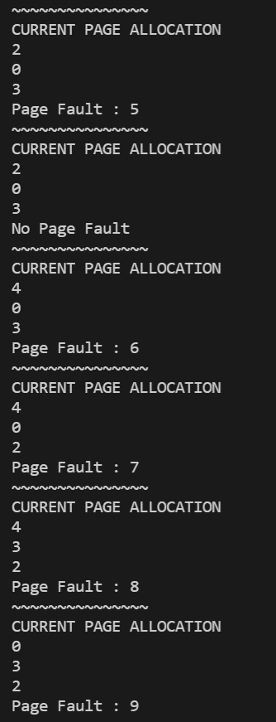 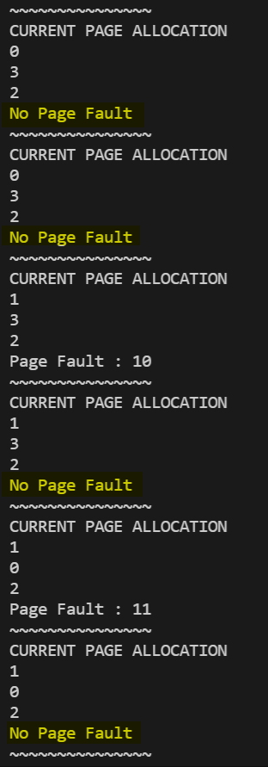

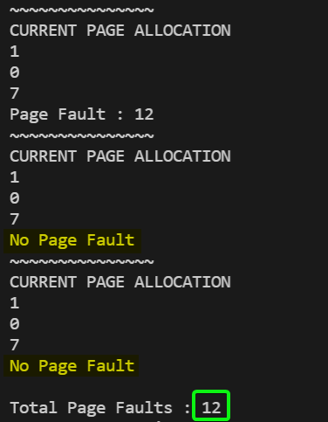

ii) Optimal Page Replacement algorithm

In this algorithm, OS replaces the page that will **not be used** for the longest period of time in future.

**Code**

*#include* <bits/stdc++.h>

using namespace std;

*// F(x) to Print Vector*

void print(vector<int> v);

*// F(x) to Predict the Optimal Page that Would be Required in Future*

int predictFuture(int pages[], vector<int> frames, int n, int index);

*// F(x) to Calculate the No Of Page Faults using Optimal Algorithm*

int OptimalPageReplacement(int pages[], int n, int noFrames);

int main()

{

    cout << "Optimal Page Replacement Algorithm\n\n";

    int n;

    cout << "Enter Number of Pages : ";

    cin >> n;

    int pages[n];

    cout << "Enter Space seperated Page Reference Number : \n";

*for* (int i = 0; i < n; i++)

        cin >> pages[i];

    cout << "Enter number of frames : ";

    int noFrames;

    cin >> noFrames;

    int ans = OptimalPageReplacement(pages, n, noFrames);

    cout << "   " << endl;

    cout << "Total Page Faults : " << ans << endl;

*return* 0;

}

*// F(x) to Print Vector*

void print(vector<int> v)

{

    cout << "~~~~~~~~~~~~~~~" << endl;

    cout << "CURRENT PAGE ALLOCATION" << endl;

*for* (auto x : v)

        cout << x << endl;

};

*// F(x) to Predict the Optimal Page that Would be Required in Future*

int predictFuture(int pages[], vector<int> frames, int n, int index)

{

    int res = -1;

    int far = index;

*for* (int i = 0; i < frames.size(); i++)

    {

        int j;

*for* (j = index; j < n; j++)

        {

*if* (frames[i] == pages[j])

            {

*if* (j > far)

                {

                    far = j;

                    res = i;

                }

*break*;

            }

        }

*if* (j == n)

        {

*return* i;

        }

    }

*if* (res == -1)

    {

*return* 0;

    }

*return* res;

}

*// F(x) to Calculate the No Of Page Faults using Optimal Algorithm*

int OptimalPageReplacement(int pages[], int n, int noFrames)

{

    vector<int> frames;

    int pageFaults = 0;

*for* (int i = 0; i < n; i++)

    {

*// If the Page is Found*

*if* (find(frames.begin(), frames.end(), pages[i]) != frames.end())

        {

            print(frames);

            cout << "No Page Fault" << endl;

        }

*// If set holds less pages than capacity.*

*else* *if* (frames.size() < noFrames)

        {

            frames.push_back(pages[i]);

            pageFaults++;

            print(frames);

            cout << "Page Fault : " << pageFaults << endl;

        }

*// Find the Optimal Page to be Replaced*

*else*

        {

            int index = predictFuture(pages, frames, n, i + 1);

            frames[index] = pages[i];

            pageFaults++;

            print(frames);

            cout << "Page Fault : " << pageFaults << endl;

        }

    }

*return* pageFaults;

}

**Output**

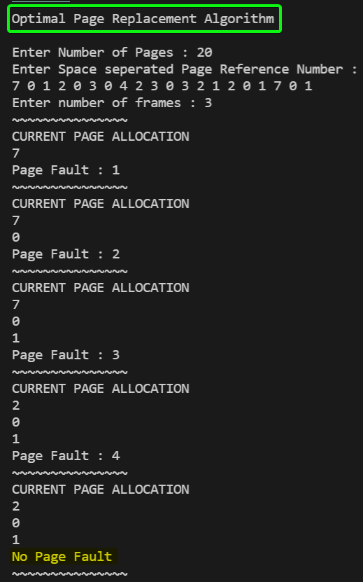

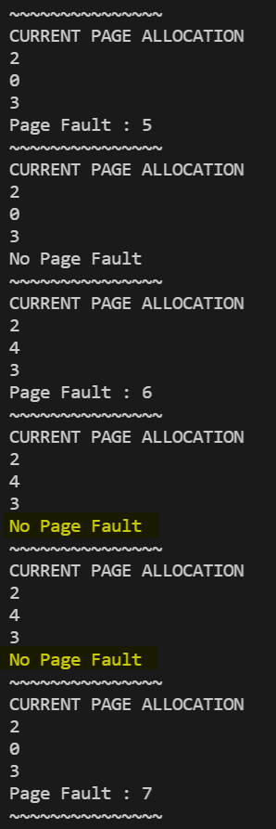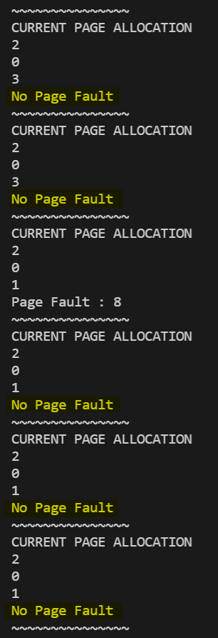

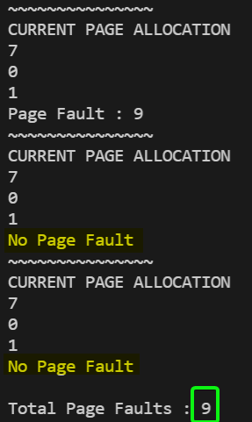

|  |  |  |
| --- | --- | --- |
| **Input Page Request** | 7 0 1 2 0 3 0 4 2 3 0 3 2 1 2 0 1 7 0 1 (20 Pages) | |
| **No. of frames** | 3 | |
| **Page Faults** | **12** (LRU Algorithm) | **9** (Optimal Page Replacement Algorithm) |

SUBMITTED BY:

**U19CS012**

BHAGYA VINOD RANA